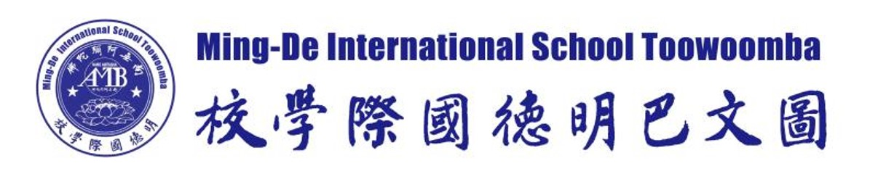
Philosophy
The philosophy of Ming-De International School Toowoomba Inc (Ming-De) is based on providing our students with a learning atmosphere that will enrich not just their minds, but to be the best person they can be. We believe that our students are valuable members of society and recognize that all young people deserve a positive educational experience, one which will motivate and inspire them to reach their full potential.

Our aim is to foster spiritual, intellectual, physical and social development in each student through participation in programs of study and other activities appropriate to their diverse needs, abilities and aspirations in order to foster the core values of Sinology and the teachings of the Buddha.

Ming-De believes that all young people have unique attributes and strengths that should be celebrated by allowing them to enjoy and be challenged through learning. Our community believes that educational opportunities should help young people to develop a sense of pride and respect (for self and others), challenge them to broaden their horizons (socially, emotionally and academically) and realize their dreams of finding their place in an ever-changing global society.

Aims
Working within the Australian Education System and the goals of the Alice Springs (Mparntwe) Declaration and the National Goals, Ming-De is committed to promoting excellence and equality in our education to:
- Commit to promoting excellence and quality teaching values through the use of the Australian Education system
- Create successful young Australians to become successful learners, respectful, confident and creative individuals, and active and informed citizens in their community
- Provide equal access to quality education to all students regardless of race, gender, or culture
- Assist any students for whom mainstream education does not meet their spiritual needs by improving their spiritual and educational outcomes
- Assist students to reach their full potential; by providing a nurturing environment
- Create learning that will be meaningful to the students, with an emphasis on critical and creative thinking; personal and social development; and moral and intercultural understanding
- Help students to develop a strong connection and sense of belonging in the community by building a school culture that encourages students to actively participate in learning and school activities

It is the aim of Ming-De that our students will have respect for self and others, and be confident, enthusiastic and creative learners. We hope our students will:
- Embrace the principles of Sinology and the teachings of the Buddha in their daily living
- Be committed to an active and healthy lifestyle, one which respects all living things and the environment
- Be knowledgeable and prepared for further learning as they continue on their educational journey.
- Contribute to the social and environmental well-being of the local and global communities and accept the challenges of a rapidly changing world.
- Lead by example, embracing the tenets of Guidelines for Being a Good Person’

The staff and community of Ming-De will assist to:
- Recognize, encourage, value and support the role of parents and their involvement in our school, cooperating with parents to provide education for their children
- Acknowledge that each student is to be loved and valued as an individual, and also to teach them to support, encourage and cooperate with one another
- Foster positive communication between staff and students, with staff members serving as role models to students
- Support and attend ongoing professional development for all staff members

The staff and community of Ming-De will assist to:
- Provide students with the opportunity to undertake studies in a broad range of disciplines that promote intellectual development, a love of learning and a spirit of inquisitiveness
- Provide a Sinology centered, bi-lingual curriculum catering to all levels of ability and designed to enhance the development of initiative, character and personality
- Assist our students to develop strong moral values, self-confidence, optimism, self-esteem and self-discipline within their lives as a basis for their potential life roles as family, community and workforce members
- Participate in benchmarking and standardized testing to both monitor student progress and teacher pedagogy
- Empower students to be responsible and effective in the use of information and communication technologies which will equip them for the future and its complex environmental and social challenges
- Equip students to be life-long learners by developing problem-solving skills
- Develop an understanding of our responsibility to the environment which we have been entrusted to manage and caretake for future generations through sustainable development and ecological sensitivity
- Attain high standards of knowledge, skills and understanding through a comprehensive and balanced curriculum in the compulsory years of schooling and the key learning areas of English, mathematics, science, studies of the society and environment, the arts, health and physical education, and languages
- To attain the skills of numeracy and English literacy; such that every student should be able to numerate, read, write, spell and communicate at an appropriate level
- To provide a broad spectrum of opportunities to develop the unique gifts and talents each student possesses in order to maximize their future potential
- The staff and community of Ming-De will assist to:
  - Provide a loving and secure environment where our students can be encouraged to adopt a program of personal health and fitness through participation in sports and recreational activities
  - Encourage the effective use of leisure time both in the school and the community

The wider school community will:
- Form a community where all participating bodies—the board, the staff, the students, the parents and friends—are involved in creating a harmonious and stimulating atmosphere in which our students can develop a feeling of self-worth, a sincere respect for others, and a sense of personal responsibility and commitment to their school and to the wider community.
- Foster a positive relationship with members of the local community and have an understanding of Australian laws and customs

Educational environment in the school should be socially just so that:
- Students’ outcomes from schooling are free from the effects of negative forms of discrimination based on gender, language, culture and ethnicity, religion or disability; and of differences arising from students’ socio-economic background or geographical location
- All students understand and acknowledge the value of cultural and linguistic diversity, and possess the knowledge, skills and understanding to contribute to, and benefit from, such diversity in the Australian community and internationally
- All students have access to the high-quality education necessary to enable the completion of school education to Year 12 or its vocational equivalent, providing clear and recognized pathways to employment and further education and training

Vision
At Ming-De, we will provide a nurturing environment, enriching our students with care. The Australian Curriculum will be taught using a bi-lingual teaching approach based on Content Language and Integrated Learning (CLIL) principles. The core values of Sinology and the teachings of the Buddha will be the underlying ethos of our school. Through the principles of Sinology, we will:
- Love and respect our parents
- Respect teachers and elders
- Be kind to our siblings
- Be mindful and trustworthy in our daily lives
- Build strong relationships with and learn from kind and virtuous people

Mission
At Ming-De, our focus is to:
- Foster a community of students with equal opportunities who will be engaged lifelong learners
- Encourage students to become capable, competent, co-contributors and active participants in their own learning who are able to problem solve and think creatively and critically
- Instill children with a strong sense of duty and belonging, and a sense of achievement in all they do
- Provide opportunities for exploring and investigating while being respectful to self, others and the environment
- Foster strong, respectful relationships with students, their families, and the wider community
- Encourage responsibility toward the natural environment and awareness of sustainability by being kind, compassionate, caring, and confident local and global citizens
- Empower our children with communication skills that enable them to take responsibility for themselves, to cooperate with others and to effectively resolve conflicts
- Involve our students in diverse, in-depth and cohesive learning programs aligned to year level content and achievement standards informed by the Australian curriculum
- Ensure our students are taught by teachers who are highly effective and focused on improving student learning through their commitment to ongoing professional development

